 | 26.5 Editors - Properties Editor - Scene Properties Tab
Table of content
Scene Tab 2
Render Engine 3
Scene Panel 3
Scene Data Prop 3
Scene Browser 3
Edit Box 3
Pin Scene to Workspace 3
New Scene 3
New 3
Copy Settings 3
Linked Copy 4
Full Copy 4
Duplicate4 4
Delete Scene 4
Camera 4
Background Scene 4
Active Movie Clip 4
Units Panel 4
Unit System 5
Unit Scale 5
Separate Units 5
Rotation 5
Length 5
Mass 5
Time 5
Temperature 5
Gravity Panel 5
Enable 6
Gravity X, Y Z 6
Animate Property 6
Simulation Panel 6
Simulation Range 6
Start 6
End 6
Keying Sets Panel 6
Keying Set List 7
Add / Remove Keying Set 7
Description 7
Export to file 7
Active Keying Set 7
Paths 7
Add / Remove Paths 8
Target ID Block 8
Data Path 8
Array all Items 8
FCurve Grouping 8
Keyframe Settings 8
Only Needed 9
Visual Keying 9
XYZ=RGB Colors 9
Audio Panel 9
Volume 9
Animate Property 9
Distance Model 9
Doppler Speed 9
Doppler Factor 9
Update Animation Cache 9
Rigid Body World Panel 10
Activate 10
Activate / Remove Rigid Body World 10
Settings 10
Animate Property 10
Collection 10
Constraints 11
Speed 11
Split Impulse 11
Substeps Per Frame 11
Solver Iterations 11
Cache 11
Simulation Start / End 11
Bake 11
Calculate to Frame 11
Current Cache to Bake 11
Bake All Dynamics 11
Delete All Bakes 12
Update All To Frame 12
Field Weights 12
Light Probes - EEVEE 12
Spheres Resolution 12
Bake All Light Probe Volumes 13
Delete Light Cache 13
Animation 13
Action Name Selector 13
Slot Name Selector 13
Dropdown Selector Operators 13
Custom Properties Panel 13
Add 14
Edit 14
Remove 14

Scene Tab
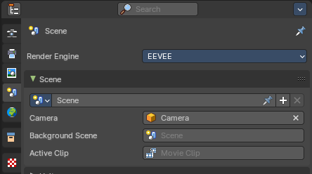
Scenes are a way to organize your work. Usually you work with just one scene. But each. .blend file can contain multiple scenes which share other data, such as objects and materials.

The scenes can be managed in the scene drop down box up right in the header.
Appending happens through the File menu / Append.

Render Engine
Shows the active render engine. Specific renderer does have other settings. And you can also switch to another renderer. But note that this is more a visual guide. It misses the Cycles render settings.

Scene Panel
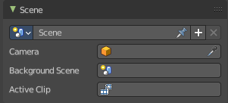

Scene Data Prop
A list of the available scenes.

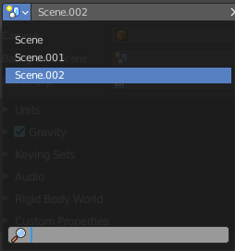
Scene Browser
A list of the available scenes.

Edit Box
The name of the currently active scene.

Pin Scene to Workspace
Allows you to pin this particular scene to a workspace. So that this scene gets loaded when you enter this workspace.

New Scene
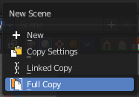
Creates a new scene. It will call a sub menu where you can choose with what settings you want to initialize the new scene.

New
Creates an empty scene with default values.

Copy Settings
Creates an empty scene but also copies the settings from the active scene into the new one.

Linked Copy
This option creates a new scene with the same settings and contents as the active scene. However, instead of copying the objects, the new scene contains links to the objects in the old scene. Therefore, changes to objects in the new scene will result in the same changes to the original scene, because the objects used are literally the same. The reverse is also true.

Full Copy
Using this option, nothing is shared. This option creates a fully independent scene with copies of the active scenes contents. Every object in the original scene is duplicated, and a duplicate, private copy of its object-data is made as well.
Note
To choose between these options, it’s useful to understand the difference between Objects and Object Data. See Duplication.
The choices for adding a scene, therefore determine just how much of this information will be copied from the active scene to the new one, and how much will be shared (linked).

Duplicate4
Dysfunctional in this context.

Delete Scene
Deletes the currently selected scene.

Camera
Here you can define the active camera for rendering.

Background Scene
Here you can choose a background scene.

Active Movie Clip
Here you can choose an active movie clip for constraints and viewport drawing.

Units Panel

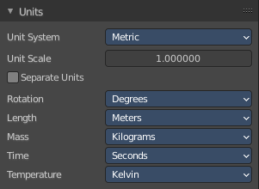
Here you define the units for the scene.

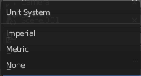

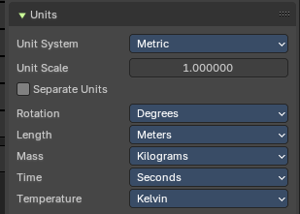
Unit System
The overall unit system that gets used.

Unit Scale
The standard unit scale.

Separate Units
Display Units in pairs.

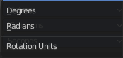
Rotation
Units to display on rotation. Radians or Degree.

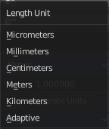
Length
Units to display the length values.

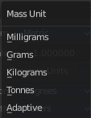
Mass
Units to display the mass values.

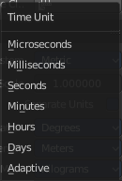
Time
Units to display Time values.

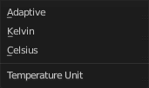
Temperature
Units to display temperature.

Gravity Panel

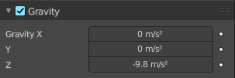
Here you can adjust the gravity settings. The default values are the standard gravity than on earth with the usual acceleration of 9.81 meters per second in Z direction.
Gravity is used for physics simulations like rigid body.

Enable
In the header is a checkbox to enable the gravity.

Gravity X, Y Z
The gravity values.

Animate Property
These properties can be animated. Activating this button sets a keyframe.

Simulation Panel
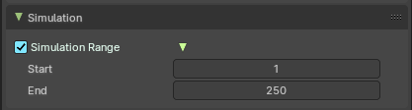

Simulation Range
Allows you to use a simulation range that is different from the scene range for simulation nodes that don't override the frame range themselves.

Start
The start frame for the simulation.

End
The end frame for the simulation.

Keying Sets Panel
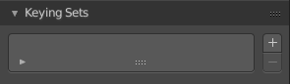

Keying Sets are a collection of properties. They are used to keyframe multiple properties at the same time.
There are some built in Keying Sets, and also custom Keying Sets called Absolute Keying Sets.
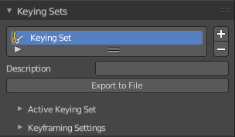
This panel here is used to add, select and manage Absolute Keying sets.
When you add a custom keying set in the list box, then you will reveal further options.

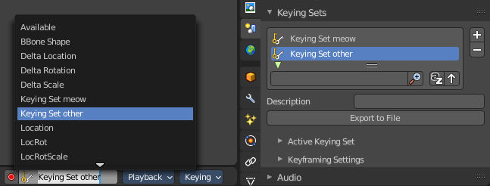
Every keying set that you add here is also available in the list of active keying sets in the header of the timeline editor.

Keying Set List
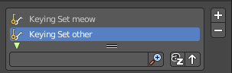
Here you can see the list of your Absolute Keying Sets. The active keying set is highlighted in blue.
It has a search form below the list. Click the arrow button down left to expand the search.
The list display can be resized by clicking at the dotted area and drag it up or down.

Add / Remove Keying Set
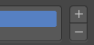
At the right side you can add or remove a keying set with the + and - buttons

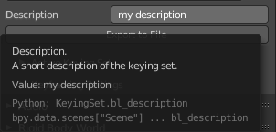
Description
Here you can add a description to your keying set.

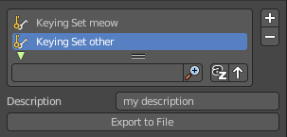
Export to file
Here you can export the keying set to a Python file.
To re add the keying set from the File.py, open then run the File.py from the Text Editor.

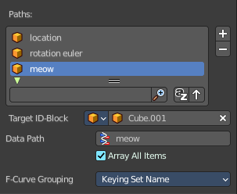
Active Keying Set
Here you can add properties to the active keying set.

Paths
A list with a collection of Paths each with a Data Path to a property to add to the active Keying Set. The active Path is highlighted in blue.
It has a search form below the list. Click the arrow button down left to expand the search.
The list display can be resized by clicking at the dotted area and drag it up or down.

Add / Remove Paths
At the right side you can add or remove a keying set with the + and - buttons

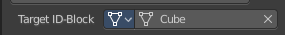
Target ID Block
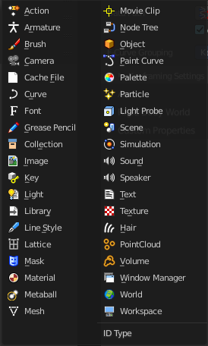
Set the ID-Type + Object ID Data Path for the property. Means pick the object or data type that you want to influence here. When it is a mesh object then you should choose mesh here.
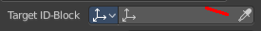
At the left you have a list of the available ID Types. At the right you have a picker as long as you haven't defined the object where you want to use this property at. Use this picker to pick up the object.
Or choose your mesh object from the list of scene objects.

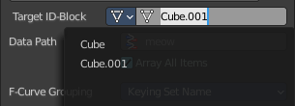

Data Path
Here you can assign a data path variable. This variable points to a python animation property that can be used for the mesh object. Location or rotation euler are valid terms for a mesh object. meow not. It will simply not work. For the available properties for the different object types please have a look in the python API.

Array all Items
For an Array / Vector type, use All Items from the Data Path or select the array index for a specific property.

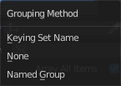
FCurve Grouping
This controls what Group to add the Channels to. Keying Set Name, None, Named Group.

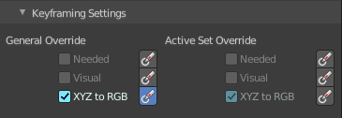
Keyframe Settings
General Override and Active Set Override have the same items each. General override works for all keying sets. Active sets just overrides the current active keying set.
The check boxes activates the item to make it available. The buttons behind sets the item on or off.

Only Needed
Only insert keyframes where they’re needed in the relevant F-Curves.

Visual Keying
Insert keyframes based on the visual transformation.

XYZ=RGB Colors
For new F-Curves, set the colors to RGB for the property set, Location XYZ for example.

Audio Panel
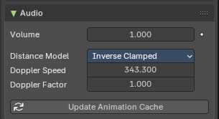
Here you can adjust the general audio settings.

Volume
The Audio Volume.

Animate Property
This property can be animated. Clicking at the button will set a keyframe at the current frame position.

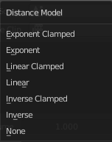
Distance Model
The algorithm for attenuation calculation.

Doppler Speed
Speed of sound for Doppler effect calculation.

Doppler Factor
Pitch factor for Doppler effect calculation.

Update Animation Cache
Update the audio animation cache. Something that you might want to do after changes at the settings.

Rigid Body World Panel

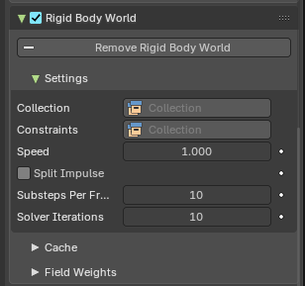
The rigid body world is a group of Rigid Body objects, which holds settings that apply to all rigid bodies in this simulation.
When you add Rigid Body physics on an object, primary there is created a group of objects with default “RigidBodyWorld” name. Rigid body objects automatically are added to this group when you add Rigid Body physics for them.
You can create several Rigid Body World groups, and allocate the Rigid Body objects with Groups panel in Object context.
Rigid body objects and constraints are only taken into account by the simulation if they are in the groups specified in Group field of the Rigid Body World panel in the Scene context.

Activate
In the header is a checkbox where you can enable or disable the Rigid Body World.

Activate / Remove Rigid Body World
Activate or Remove Rigid Body simulation from the current scene.

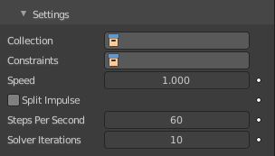
Settings
A sub menu with further settings.

Animate Property
The properties with an animate property at the right can be animated. Clicking at the button will set a keyframe at the current frame position.

Collection
Containing rigid body objects participating in this simulation.

Constraints
Containing rigid body object constraints participating in the simulation.

Speed
Can be used to speed up/slow down the simulation.

Split Impulse
Enable/disable reducing extra velocity that can build up when objects collide (lowers simulation stability a little so use only when necessary). Limits the force with which objects are separated on collision, generally produces nicer results, but makes the simulation less stable (especially when stacking many objects).

Substeps Per Frame
Number of simulation steps made per frame (higher values are more accurate but slower). This only influences the accuracy and not the speed of the simulation.

Solver Iterations
Amount of constraint solver iterations made per simulation step (higher values are more accurate but slower). Increasing this makes constraints and object stacking more stable.

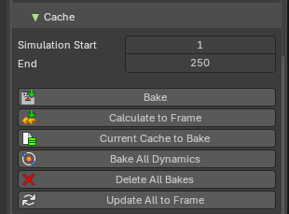
Cache
A sub menu with cache settings. The cache is getting used for animation.

Simulation Start / End
First and last frame of the simulation.

Bake
Calculates the simulation and protects the cache. You need to be in Object mode to bake.

Calculate to Frame
Bake physics to current frame.

Current Cache to Bake
Bake from Cache.

Bake All Dynamics
Bake all physics.

Delete All Bakes
Free all baked caches of all objects in the current scene.

Update All To Frame
Update cache to current frame.
If you haven’t saved the blend file, the cache is created in memory, so save your file first or the cache may be lost.

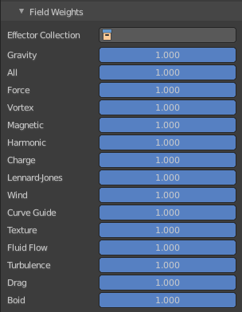
Field Weights
With force fields you can influence rigid body objects in physics simulations. Every force field has its own local settings, which can be adjusted in the physics panel. Here you can adjust the general field weights for those forces.

Light Probes - EEVEE
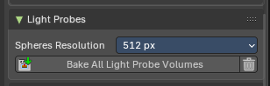
These settings control how light probes behave globally in your scene. Light probes are used to simulate indirect lighting and reflections in real-time rendering by baking lighting data ahead of time.

Spheres Resolution
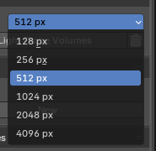
Sets the resolution (in pixels) of the light probes. Higher values produce sharper reflections but increase memory usage and bake time.
Sizes:
- 128 px – Fast preview
- 512 px – Balanced quality
- 1024+ px – High-quality reflections

Bake All Light Probe Volumes
Initiates the baking process for all light probes in the scene. Computes indirect diffuse lighting based on probe placement and resolution.

Delete Light Cache
Remove cached baked indirect lighting.

Animation
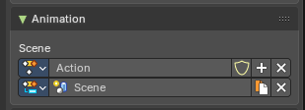
Action Slots allow a single Action to store animation data for multiple data-blocks (e.g. objects, materials, cameras). In this case this stores Scene container animation keyframes.
Each slot acts like a container for animation channels tied to a specific target Action Clip.

Action Name Selector
A unique Action Clip Contains the actual animation data: F-Curves, groups, and keyframes.

Slot Name Selector
A unique identifier for the slot within the Action. Used to match the slot with a data-block during evaluation or assignment. Can be manually named or auto-assigned based on the data-block name.

Dropdown Selector Operators
- Dropdown Selector: List of available slots or actions
- Selector Name: Name of the slot or action
- Add Action/Slot: Adds a new Action Clip/Slot, or select one from the drop down
- Shield icon: Stores the Data with protection (prevents deletion when reloading the file if there are no users).
- Remove: Removes the active Action clip or Slot
- Duplicate: Duplicates the Active slot with keyframes.

Custom Properties Panel


Here you can define custom properties that can be used for scripting.

Here you might also find custom properties from addons or scripts.

Add
Adds a new property.


Edit
Opens a panel where you can adjust the settings for the custom property.

Remove
Removes the property.

